Training on Sandalwood Cultivation and Management
(15.06.2026 to 19.06.2026)
(5 days)
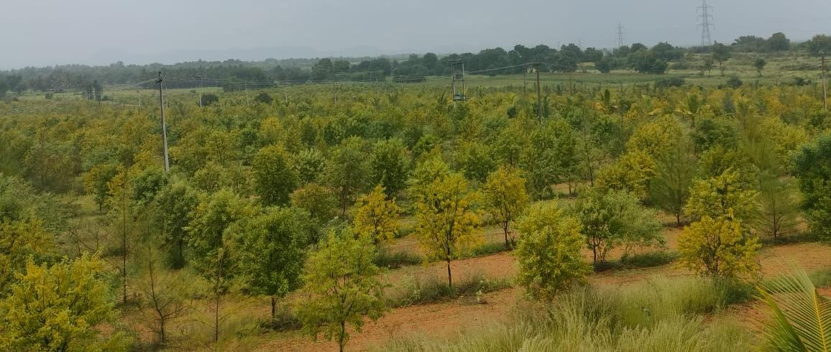 | 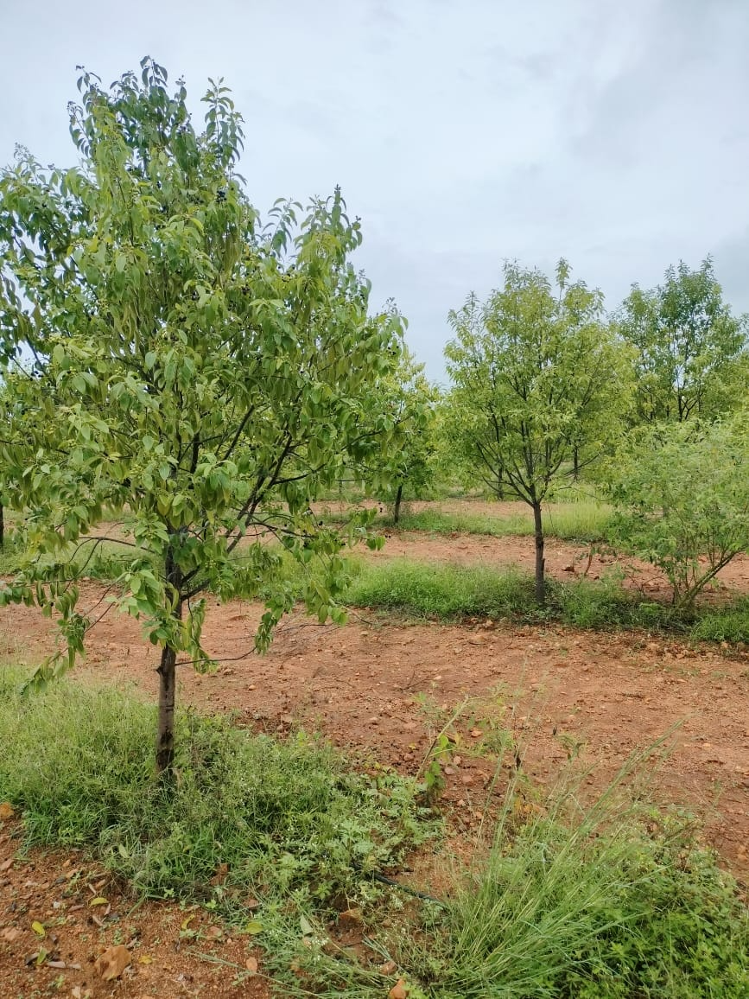
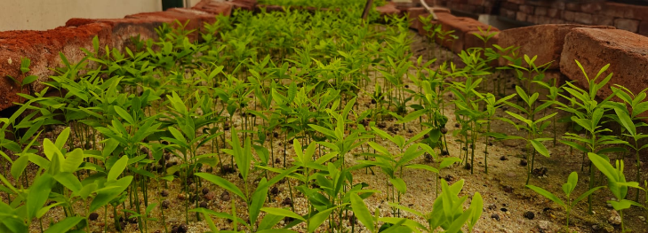

Course Directors: Dr. N. Ravi, Dr. Ashrith, K.N. and Dr. Archana R
Contact: 080-2290160, 9435524070, 6361427332, 8197872124
nravi@icfre.org, ashrithkn@icfre.org; archanar@icfre.org
Date: Course 15 – 19 June, 2026 (5 days)
Fees: Rs. 15,000/-(With boarding and lodging) + 18% GST
Fees: Rs. 10,000/-(Without boarding and lodging) + 18% GST
Course content: Seed handling and nursery techniques on raising of sandalwood seedlings and hardening of seedlings; Management of seedlings in the nursery and growing of healthy seedlings for planting. Raising of Sandalwood Plantation; Management of plantation; Pest and disease management in nursery and plantation; Agroforestry using Sandalwood; Heartwood formation in Sandalwood; Harvest and marketing; Sandalwood Policy; Field trip to Sandalwood plantation
Registration: The application/nomination letter should be sent to the respective Course Director, Institute of Wood Science and Technology, 18thCross, Malleswaram, Bangalore-560 003 at least 15 days before the commencement of the respective course. The requisite course fee can be paid either in cash or through Demand Draft drawn in favour of “The Director, IWST-Training” payable at Bangalore. The fee can also be remitted by online transfer to the following bank account.
The Director, IWST training
Bank Name: Union Bank of India, Malleshwaram, Bengaluru
Account Name: 392002010007384
IFSC Code: UBINO539201

Note: Participants are advised to commence their journey for the training only after receiving conﬁrmation about the course. If adequate response for a particular course is not received, the same is liable to be cancelled. In that case, the course fee will be refunded to the concerned.

Intimation of payment: Participants are requested to send the copy of the receipt to anyone of the emails: nravi@icfre.org, ashrithkn@icfre.org; archanar@icfre.org with a CC to jyothyp@icfre.org

Facilities: The Institute has well equipped laboratories, wood processing machineries, timber seasoning and preservation plant, nursery for raising seedlings and mistchamber for clonal propagation, xylarium, woods museum and interpretation centre, library, computer center, woodworking workshops etc .It also has nurseries and experimental ﬁeld stations for conducting wood science and forestry research as well as training. A Scientists' Hostel and a Guest House within the campus can accommodate the trainees well.
Faculty: The Institute has qualiﬁed and trained scientists with national and international exposure. Apart from the scientists of the Institute, renowned experts from other reputed institutions/universities are also engaged as resource persons/guest faculty
About Institute: The Institute of Wood Science and Technology (IWST), Bengaluru, under Indian Council of Forestry Research and Education (ICFRE) was formed in 1988 on reorganization of forestry research in the country. The IWST is mandated to conduct research on Wood Science and Technology as national objective and focuses its research activities to important forestry research needs of the states of Karnataka, Andhra Pradesh and Goa at regional level. Taking into consideration the expertise available and contribution made by the Institute, the ICFRE has recognized IWST as Centre of Advanced Studies in the areas of a) Improved utilization of wood, and b) Research on sandal. The Institute maintains three ﬁeld stations for forestry research in Karnataka state. The thrust areas of research of the Institute are wood properties and uses, wood processing, wood composites, chemistry of forest products, forest protection and silviculture and forest management
For More details on trainings in IWST – Pl. click https://iwst.icfre.gov.in/course-calendar.html

